Copenhagen Multimodality Day
Theoretical and methodological issues in multimodal analysis
____________________________________________________________

Centre of Interaction Research and Communication Design
University of Copenhagen, 2 November, 2015
Proposal Deadline: 20 June, 2015 __________________________________________

This research seminar invites proposals for paper presentations related to the general theme of theoretical and methodological issues in multimodal analysis. We intend for this theme to generate a broad range of presentations and discussions related to the further development of the multimodal paradigm as a comprehensive theory and method.

The invited keynote speaker is Professor Jon Hindmarsh of Kings College London.

In this context, multimodality is primarily understood within the social interaction paradigm and as a CA term that relates to the social and embodied organization and construction of actions such as speech, gesture, and use of material structure. Research on multimodality based on video data is not new (e.g. Goodwin, 1979, 1980; Heath, 1984), but has nonetheless been on the rise for at least the past decade (cf. review in Deppermann, 2013).

Prominent scholars have made vast contributions to the understanding of participants’ use of speech, body, gaze, gestures and the semiotically rich structures of the material environment. However, to go even deeper and wider with analysis of the subtle details in interactions, questions about how to understand and analyze various kinds of situations and sensory aspects become important (Bargiela-Chiappini, 2013; Streeck, 2013).

How, for example, do smell, taste and tactile experiences affect interaction (Streeck, 1996; Nishizaka, 2011)? And what about ICT-mediated settings (e.g. Luff et al., 2003)? How do participants produce understanding and meaning not only through one or two modalities, but through many different modalities simultaneously? What is it possible and not possible to capture through video-ethnographic methods? What are the suitable ways to transcribe types of actions and the ecology of modalities? What kind of theoretical input and methodological reflections should be taken into consideration when trying to analyze social actions related to this broad phenomenological and holistic sense of being-in-the-world? For instance, is it possible and recommendable to work with an eclectic theoretical approach, or should a distinct CA multimodal (grand) theory be developed?

In line with this are questions such as: how does the notion of a simultaneous use of different modalities link up with the notion of sequentiality? How or in what ways is it possible to represent and thus analyze modalities that the participants do not explicitly account for or clearly orient themselves towards in an interaction, but which nonetheless are intuitively important – and how about transcriptions of smell and taste? How much and what kind of ethnographic knowledge is needed to fully understand multimodal interaction? And finally, does it make sense to continue to use the term multimodality when it is also used by other different academic traditions (e.g. Hodge & Kress, 2007; Jewitt, 2009)?

We welcome empirical papers, discussions and theoretical papers that take CA and known multimodality studies as points of departure for new theoretical and methodological considerations. We especially encourage proposals that try to expand and experiment with the approach to different modalities, and papers that employ philosophical and theoretical perspectives and reflections within the CA framework.

Practical information

This one-day research seminar is being prepared and organized by the Centre of Interaction Research and Communication Design at the University of Copenhagen. We are aiming for about 30-40 participants during the day, which is planned as a single-track research seminar.

The fee for the research seminar is DKK 300, to be paid when registering on
http://www.webshophum-dk.ku.dk/shop/copenhagen-multimodality-1484p.html

Research seminar programme

09:30-10:00 Coffee, registration and welcome
10:00-12:00 Paper presentations
12:30-13:30 Lunch
13:30-14:30 Keynote speech by Jon Hindmarsh
14:30-16:00 Paper presentations
16:00-16:30 Coffee break
16:30-17:30 Paper presentations
17:30-18:00 Discussions
19:00- Dinner in downtown Copenhagen

Submission, abstracts and deadlines

Abstracts should not exceed 300 words and should include the title of the paper, research topic, method, empirical data, theoretical approach, findings and references (max. five references).

The deadline for submitting abstracts is 20 June, 2015.
Notification of acceptance by 20 August, 2015
Registration and payment of fee by 20 October, 2015

Please ensure that your abstract is anonymized by removing all features from the text and the document properties that may help to identify you as the author of the text. Presentations should be 30 minutes long (20 min presentation + 10 min discussion). The research seminar language is English.

Abstracts should be emailed to Brian Due: bdue@hum.ku.dk

Travel and location maps

The seminar will take place in Multisalen, KUA,
Karen Blixens Vej 1, room 21.0.54
2300 Copenhagen S

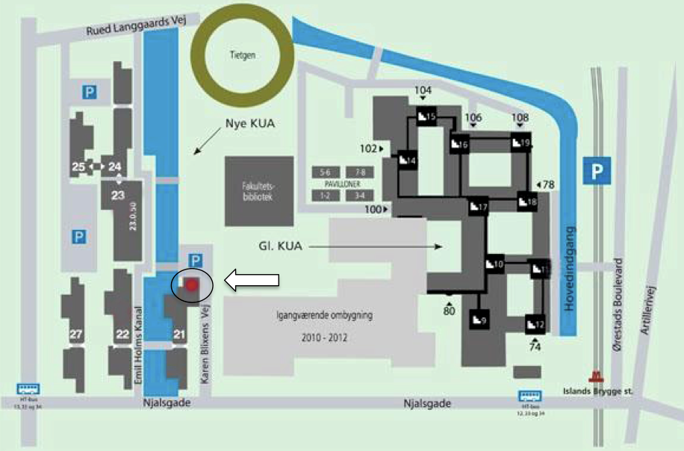

For travel information see: http://humanities.ku.dk/contact/howtofindus/

Organizing and scientific committee
The Centre of Interaction Research and Communication Design is organizing the research seminar and the scientific committee consists of Brian Lystgaard Due, Mie Femø Nielsen, Martha Sif Karrebæk and Søren Beck Nielsen.

Any comments or questions can be addressed to Brian Due at bdue@hum.ku.dk

References
Bargiela-Chiappini, F. (2013). Embodied discursivity: Introducing sensory pragmatics. Journal of Pragmatics, 58, 39–42. doi:10.1016/j.pragma.2013.09.016
Deppermann, A. (2013). Multimodal interaction from a conversation analytic perspective. Journal of Pragmatics, 46(1), 1–7. doi:10.1016/j.pragma.2012.11.014
Goodwin, C. (1979). The Interactive Construction of a Sentence in Natural Conversation. In G. Psathas (Ed.) Everyday Language: Studies in Ethnomethodology (pp. 97–121). New York, Irvington Publishers.
Goodwin, C. (1980). Restarts, Pauses, and the Achievement of a State of Mutual Gaze at Turn-Beginning. Sociological Inquiry, vol:50 hft.:3-4, 272.
Heath, C. (1984). Talk and recipiency: sequential organization in speech and body movement. In Atkinson & Heritage Structures of Social Action (pp. 247–266). Cambridge University Press.
Hodge, R., & Kress, G. (2007). Social Semiotics. Cambridge [u.a.]: Polity Press.
Jewitt, C. (2009). The Routledge Handbook of Multimodal Analysis (1st ed.). Routledge.
Luff, P., Heath, C., Kuzuoka, H., Hindmarsh, J., Yamazaki, K., & Oyama, S. (2003). Fractured Ecologies: Creating Environments for Collaboration. Human-Computer Interaction, 18(1), 51.
Nishizaka, A. (2011). Touch Without Vision: Referential Practice in a Non-Technological Environment. Journal of Pragmatics, 43(2), 504–520.
Streeck, J. (1996). How to Do Things with Things. Human Studies, 19(4), 365–384.
Streeck, J. (2013). Interaction and the living body. Journal of Pragmatics, 46(1), 69–90. doi:10.1016/j.pragma.2012.10.010

